MSc BDS – Data Engineering and Machine Learning Operations in Business

MLOps Final Assignment:
AI-Powered Customer Retention System for Telecom Subscription Services

Submitted by: Anzuman Ara
Student ID: 20241266

Submission Deadline: May 26, 2026

1. Introduction and Aim of the Project
Machine learning models are usually built and tested in stable environments, but their actual usefulness depends on how well they perform in real-world systems that are constantly evolving. In practice, data is constantly updated, new information keeps coming in, and system needs may also change. Therefore, models must be regularly maintained, updated, and monitored to ensure they continue to give reliable results.
This project follows core MLOps principles, with a focus not only on model development but also on deployment, monitoring, and reproducibility, as discussed by Kreuzberger et al. (2023).
The aim of this project is to design and implement a production-oriented machine learning system for customer retention in telecom subscription services.

In real-world business scenarios, predicting customer churn alone is not sufficient. Telecom companies need to identify customers who are at risk of leaving and take appropriate actions to retain them. Therefore, this project focuses not only on churn prediction but also on generating actionable insights that can support business decisions.

To achieve this, an end-to-end MLOps pipeline is developed. The system is designed to continuously ingest new customer data, preprocess and transform the data, train and update machine learning models, and provide real-time predictions through an API.

Additionally, the system includes monitoring mechanisms such as drift detection and conditional retraining to ensure that the model remains reliable over time. A Streamlit-based frontend is also developed to allow users to interact with the system and visualize predictions.

Overall, this project demonstrates how machine learning can be operationalized in a production-like environment rather than being limited to a standalone model.

2. Pipeline Diagram
Live Customer Data Generator / API Input
↓
SQLite raw_customers Table
↓
Preprocessing + Feature Engineering
↓
Drift Detection (Threshold = 0.20)
↓
If Drift Found → Retraining Pipeline
Else → Keep Current Model
↓
Model Registry + Versioned Artifacts
↓
FastAPI REST Prediction Service
↓
Streamlit Monitoring Dashboard
↓
Docker + GitHub Actions Automation
Figure 1: End-to-end production-oriented MLOps pipeline for customer churn prediction.

3. Technical Details of Each Pipeline Component

3.1 Data Ingestion

The system uses a production-like live ingestion strategy rather than relying only on static files. New customer records are dynamically generated and inserted into the SQLite database table named raw customers. This simulates incoming customer events from CRM, billing, or subscription systems.

The ingestion process can be triggered in three ways:

• manually by executing live_ingestion.py

• through the FastAPI endpoint /ingest-live

• automatically through a scheduled GitHub Actions workflow

Each ingestion run appends new rows into the database, allowing the dataset to grow continuously over time. This creates a realistic environment for monitoring, retraining, and production-style data updates. The pipeline also follows data-centric AI principles, where keeping data reliable and updated is important for robust machine learning systems (Zha et al., 2025).

3.2 Preprocessing
The preprocessing stage ensures consistency between training and inference. The preprocessing pipeline reads customer data directly from the SQLite database, then applies cleaning, encoding, and feature engineering steps. The following steps are applied:
- missing values are handled using default imputation
- numerical columns are converted to appropriate types
- categorical variables are encoded using one-hot encoding
- irrelevant identifiers (e.g., customer ID) are removed
SQLite was selected because it is lightweight, easy to integrate with Python, and suitable for small structured datasets. It provides better structured storage than flat files while maintaining simplicity for a student MLOps project. Consistent preprocessing is critical in MLOps systems to avoid training-serving skew. The same preprocessing logic is reused during prediction time to reduce training-serving skew.

3.3 Feature Engineering
A derived feature was introduced during feature engineering to capture additional customer value information:
average monthly value = MonthlyCharges / (tenure + 1)
This feature represents the relationship between a customer’s monthly spending and their subscription duration, helping the model better understand spending patterns over time. Customers with high monthly charges and short tenure may indicate different churn behavior compared with long-term customers who generate stable value.
Feature engineering was intentionally kept simple and interpretable in order to emphasize pipeline design, consistency, and deployment readiness rather than excessive model complexity. This approach helps maintain transparency and makes the preprocessing logic easier to reproduce in both training and prediction environments.
3.4 Model Training
A Random Forest classifier was used for model training due to its robustness, strong performance on structured tabular datasets, and ability to handle both numerical and categorical features after preprocessing. It is also less sensitive to overfitting than many single decision-tree models and performs well with relatively limited hyperparameter tuning, making it a practical choice for this project.
The training pipeline begins by loading the processed dataset, after which the target variable and input features are separated. The data is then split into training and testing subsets to allow performance evaluation on unseen records. The Random Forest model is trained using the training set, and predictions are generated on the test set to calculate evaluation metrics.
After successful training, key artifacts are stored for future deployment and reproducibility. These include the trained model file, the feature schema used during training, and evaluation metric files such as accuracy, precision, recall, and F1-score. Timestamp-based versioned copies are also saved to support model comparison and rollback if required.
Each successful training run also updates a model_registry table containing model version, accuracy score, and timestamp.
Random Forest is selected because it can effectively handle different types of data without requiring extensive preprocessing. It is also less sensitive to overfitting compared to many other algorithms and generally performs well with minimal parameter tuning, making it a practical and reliable choice for this project.

4. Evaluation, Monitoring, and Versioning Strategy

4.1 Evaluation

Model performance is evaluated using multiple classification metrics, including accuracy, precision, recall, and F1-score. This is especially important in customer churn prediction, where class imbalance can make accuracy alone misleading. Recall is particularly relevant because missing customers who are likely to churn may have direct business consequences. The evaluation results are stored as artifact files after each training run, which supports traceability and comparison across model versions.

In the latest training run, the model achieved an accuracy of 82.35%, precision of 75.0%, recall of 50.0%, and an F1-score of 60.0%.

4.2 Monitoring

Monitoring is implemented at three levels.
First, prediction logs are stored to record input data, prediction result, and timestamps for traceability.
Second, ingestion activity is monitored through newly added rows in the raw_customers table.
Third, automated drift detection compares historical customer data with recent incoming batches using relative mean shift for numerical features such as MonthlyCharges, TotalCharges, and tenure.
If drift score exceeds the threshold of 0.20, the system stores a drift alert report and retraining can be triggered automatically.
This demonstrates how monitoring supports continuous model reliability beyond simple logging.
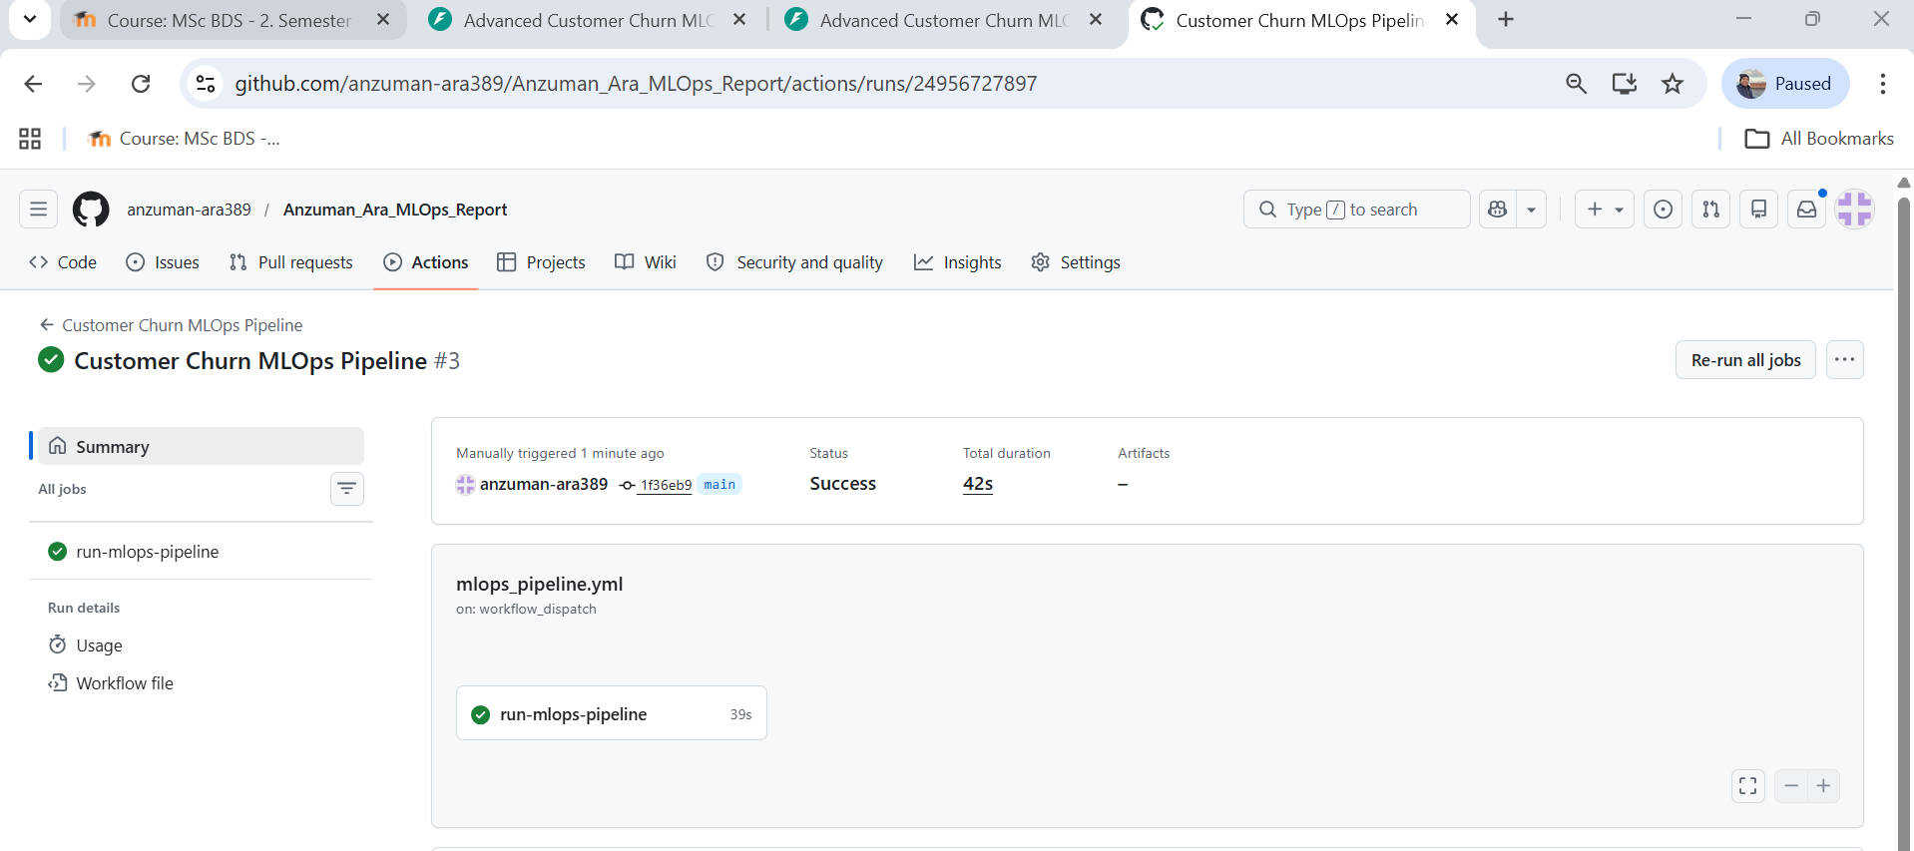
Figure 2: GitHub Actions workflow successfully executing the automated ingestion and model update pipeline.

4.3 Versioning

Artifact versioning is implemented using timestamp-based filenames. Each training run stores a versioned model file, feature schema, and evaluation metrics file. In addition, a separate latest version of the main artifacts is maintained for deployment and inference. This makes it possible to trace results back to a specific training run, compare model versions over time, and roll back if necessary.
GitHub also provides version control for source code, workflow configurations, and automated pipeline updates, improving traceability and collaboration.
Versioning supports reproducibility by making it possible to repeat the same workflow and obtain consistent results. It also allows rollback to previous versions of data or models if errors occur or if a newer version performs worse.
In addition to file-based versioning, metadata from each successful training run is stored in the SQLite model_registry table. This creates a lightweight registry similar to enterprise ML platforms.

5. Artifact Collection and Storage
Proper artifact management improves traceability and reproducibility throughout the machine learning lifecycle. By systematically storing datasets, processed files, model versions, schemas, metrics, and logs, it becomes easier to understand how predictions were generated and to reproduce the same workflow when required. This is especially important in production systems, where reliability, consistency, and the ability to troubleshoot issues are essential (Schlegel & Sattler, 2022).
Artifacts are stored in a structured directory to keep the pipeline organized and maintain clear separation between data, models, and monitoring outputs. Stored artifacts include raw data (historical and incoming records), processed datasets, trained model files (model_latest.pkl and timestamped model versions), feature schema files (columns_latest.pkl and timestamped schema versions), evaluation metrics (metrics_latest.json and versioned metrics files), ingestion logs, prediction logs, and drift monitoring reports.
This artifact storage strategy supports reproducibility by allowing previous experiments to be recreated, debugging by tracing issues back to specific pipeline stages, and auditability by maintaining clear records of model updates and system behavior over time.

6. Deployment Setup

6.1 API Deployment
The trained model was deployed using FastAPI, exposing a /predict endpoint for real-time customer churn prediction. FastAPI was selected because it is lightweight, high-performance, and well suited for serving machine learning models through REST APIs. It also provides built-in interactive documentation through Swagger UI, which simplifies testing and demonstration of endpoints. In addition, FastAPI integrates easily with Python-based machine learning workflows and supports rapid deployment.
Beyond prediction, several operational endpoints were implemented to improve system monitoring and pipeline control. The /health endpoint checks API availability, /model-info returns the latest deployed model version and performance details, /ingest-live triggers new customer data ingestion, /drift-check runs the monitoring process for data drift, and /retrain starts the preprocessing and model retraining pipeline. These endpoints make the deployed system more realistic by allowing both inference and operational management through the API.
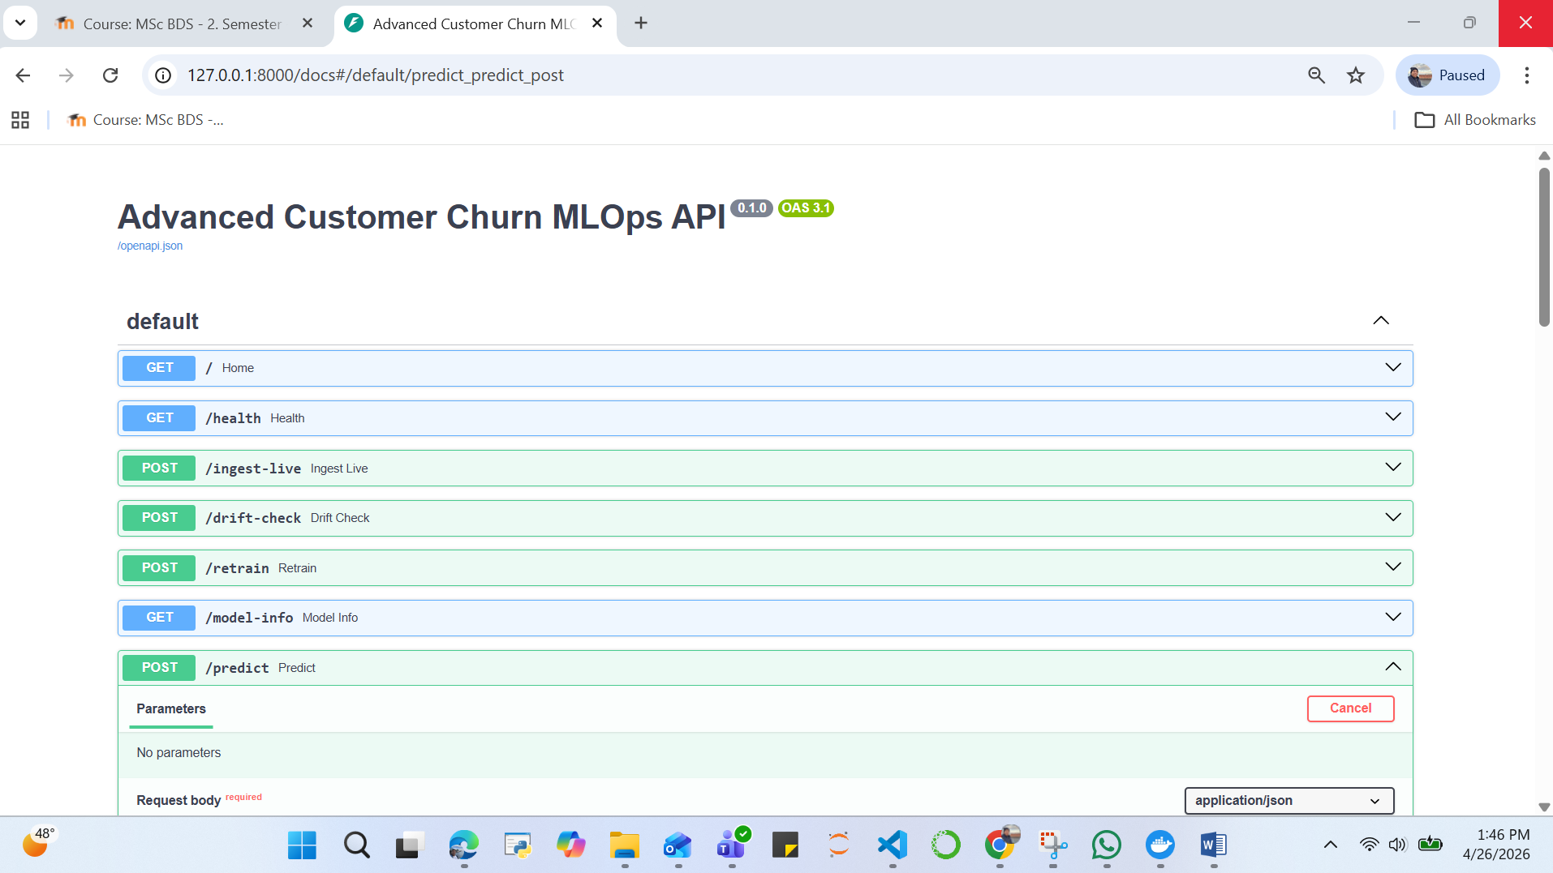
Figure 3: FastAPI Swagger UI showing successful churn prediction.

6.2 Docker Deployment

The entire system was containerized using Docker to improve portability and deployment consistency across different environments. Docker packages the application code, dependencies, and runtime configuration into a single container image, ensuring that the system behaves the same way on any machine. The deployment process includes building the Docker image, running the container, and exposing port 8000 to make the FastAPI service accessible externally. The image was built using the command docker build -t churn-mlops ., and the container was executed using docker run -p 8000:8000 churn-mlops. Docker was selected because it simplifies deployment, reduces environment-related issues, and supports reproducible machine learning operations workflows.

6.3 Execution Mode

The system supports multiple execution modes to reflect different real-world operational scenarios. First, on-demand predictions can be generated through the FastAPI API, where users or external systems send customer data and receive real-time churn predictions. Second, interactive predictions are available through the Streamlit frontend, which provides a user-friendly dashboard for manual input and monitoring. Third, automated pipeline execution is supported through GitHub Actions, which can trigger scheduled or manual workflows for data ingestion, preprocessing, model training, drift detection, and retraining. Finally, the complete application can be executed in a containerized environment using Docker, enabling consistent deployment across different machines and operating systems.

7. Frontend
A lightweight Streamlit dashboard was implemented to support both customer churn prediction and basic system monitoring. Through the interface, users can check API health status, trigger live data ingestion, run drift detection, view the latest deployed model version, and submit prediction requests in an interactive and user-friendly way. The frontend allows users to enter customer details through a simple form, send the input data to the FastAPI backend, and receive real-time churn predictions instantly. Communication between the frontend and backend is handled through HTTP requests to FastAPI endpoints such as /predict, /health, /ingest-live, /drift-check, and /model-info. Streamlit was selected because it enables fast development of Python-based dashboards with minimal frontend code and is highly suitable for demonstrating machine learning applications in a deployment environment.
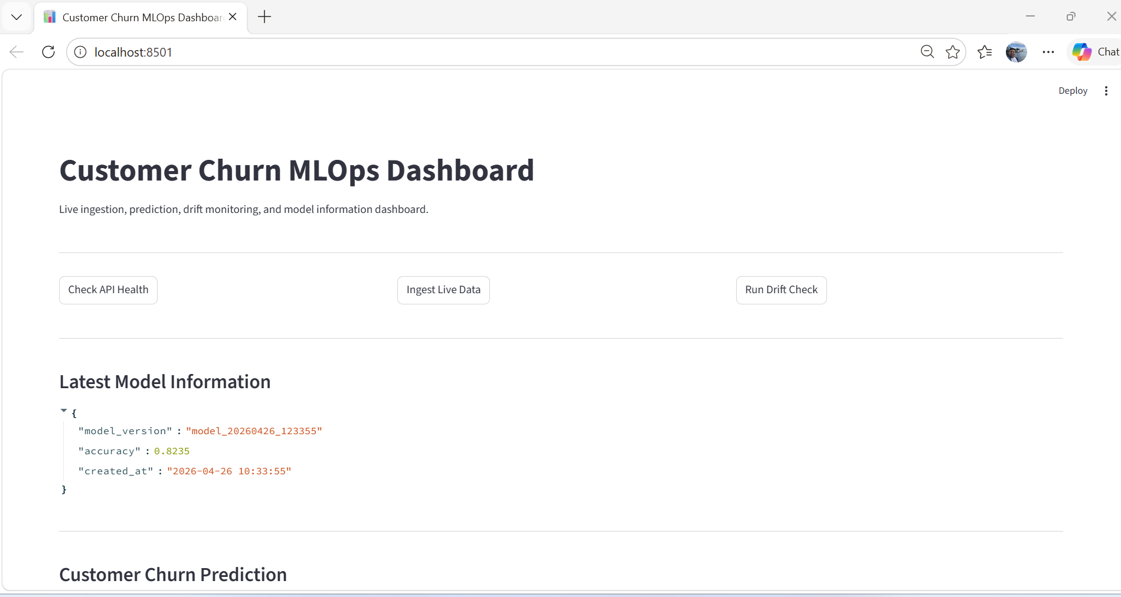
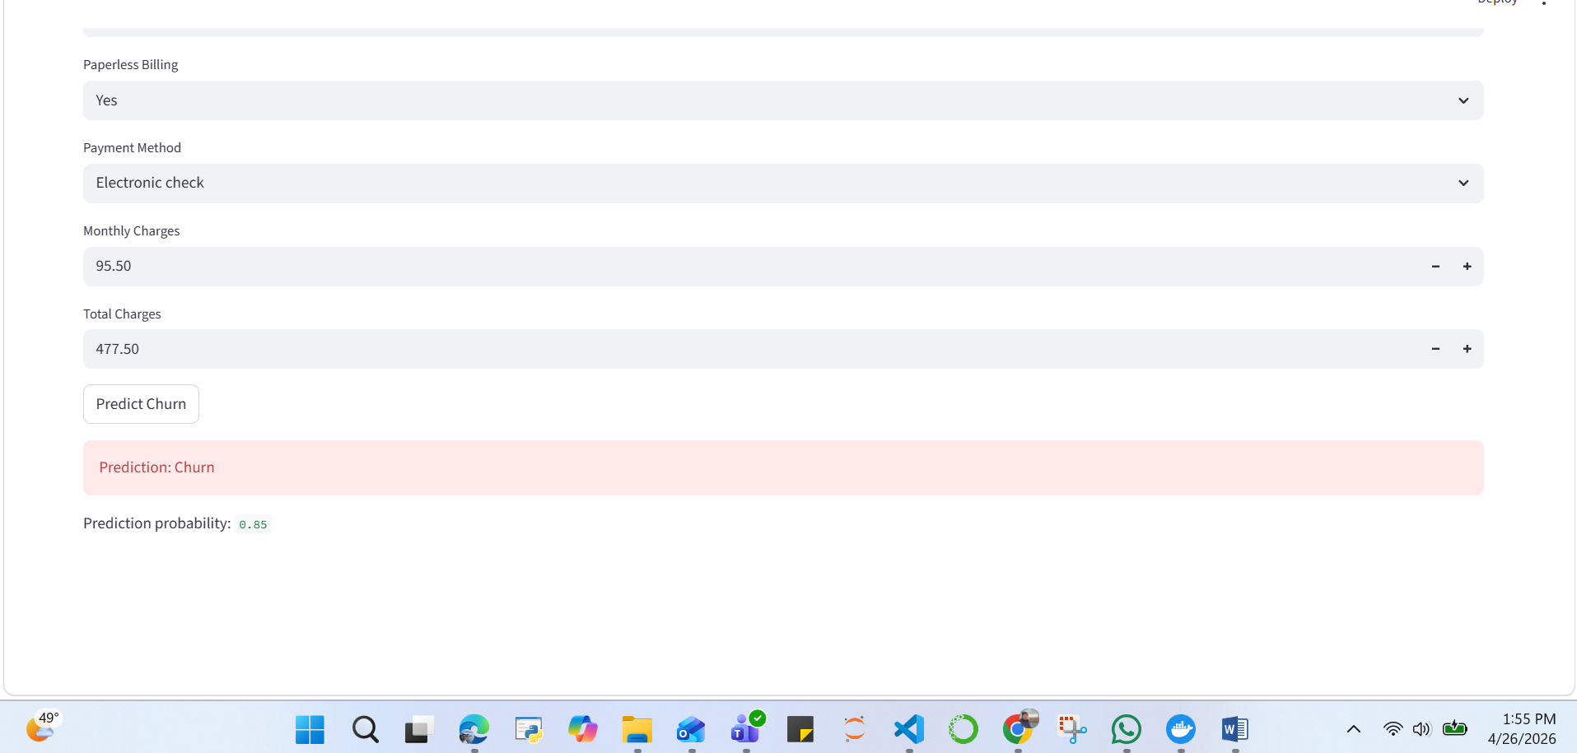
Figure 4: Streamlit frontend used for customer churn prediction.
8. Conclusion
This project demonstrates a complete MLOps pipeline focusing on system design, modularity, and deployment. The pipeline successfully brings together all the main stages of the machine learning workflow, including data ingestion, preprocessing, model training, deployment, and monitoring. By connecting these components into a single system, it ensures that data can move smoothly through each stage and that the model can be updated, used, and tracked in a reliable and organized way.
The design reflects real-world machine learning systems, where reproducibility, scalability, and maintainability are more important than model accuracy alone.
The integration of SQLite for structured storage and GitHub Actions for scheduled pipeline execution further improved the realism of the system by simulating production-style live customer data updates.
The final system also includes versioned artifacts, extended evaluation metrics, and a basic drift monitoring step, which further strengthens its reproducibility and production-like behavior. Unlike a static machine learning assignment, this project demonstrates full lifecycle management of a deployed model by combining live data updates, automated retraining logic, monitoring, deployment APIs, and reproducible artifacts.

References
Kreuzberger, D., Kühl, N., & Hirschl, S. (2023). Machine Learning Operations (MLOps): Overview, Definition, and Architecture. IEEE Access, 11, 31866–31879.
Schlegel, M., & Sattler, K.-U. (2022). Management of Machine Learning Lifecycle Artifacts: A Survey. SIGMOD Record, 51(4), 18–35.
Zha, D., Bhat, Z. P., Lai, K.-H., et al. (2025). Data-centric Artificial Intelligence: A Survey. ACM Computing Surveys, 57(5), Article 129.

